Chapter 4 AC circuit

1. Given the sinusoidal voltage $\text{v(t)=50}\text{cos}\left(30t+{10}^{∘}\right)V$ find: (a) the amplitude Vm, (b) the period T, (c) the frequency f.

Solution：

(a) The amplitude Vm equals to 50 V;

(b) $ω=2πf$, so, the period of T equals to $\frac{1}{f} = \frac{2π}{ω} =\frac{6.28}{30} =209.3ms$;

(c) The frequency is 4.8Hz.

1. Express the following functions in cosine form:

(1) $10\text{sin}(ωt+{30}^{∘})$

(2) $-20\text{sin}(ωt+{45}^{∘})$

Solution: AC sinusoid is always expressed as $A_{m}cos(ωt+φ)$ Am is referred to the peak value of the signal; $ω$ is referred to the angualar frequency and $φ$ is the phase shift. So, we need to transfer these two sine forms into the typical cosine form.

$$sinA=cos\left(A-{90}^{∘}\right)$$

$$-sinA = cos(A+{90}^{∘})$$

(1) $10\text{cos}(ωt-{60}^{∘})$

(2) $20\text{cos}(ωt+{135}^{∘})$

1. For the following a pair of sinusoid, determine which one leads and by how much.

$$v_{1}\left(t\right)=4\text{cos}\left(377t+{10}^{∘}\right),$$

$$v_{2}(t)=-20\text{cos}377t$$

Solution:

$v_{2}(t)$ is not in a typical form of AC expression, it should be tranformed as

$$v_{2}(t)=20\text{cos}\text{(}377t+ {180}^{∘})$$

So, $v_{2}(t)$ leads forward $v_{1}(t)$ by ${170}^{∘}$

1. Find current i in the circuit of Fig.4-1, when $v_{s}(t)=50\text{cos}200t$ V.

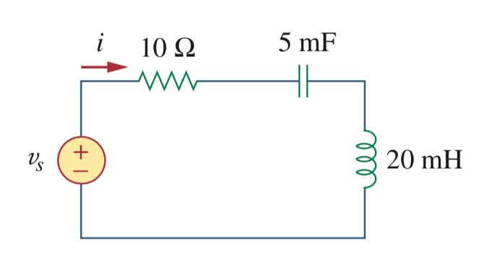

Figure 4-1

Solution:

$$ω= 200 rad/s$$

The reactance of capacitor XC and reactance of inductor XL are respectively,

$$X_{C}= \frac{1}{jωC} = \frac{1}{j∙200∙5×{10}^{-3}} =-j Ω$$

$$X_{L}= jωL =j∙200∙20×{10}^{-3} =4j Ω$$

The impedence of the RLC serie circuit is

$$Z = R + X_{C}+ X_{L}= 10+ 3j Ω$$

The current i equals to

$$i_{s}(t) =\frac{v_{s}(t)}{Z} = \frac{50∠0^{∘}}{10.4∠{16.7}^{∘}} =4.8∠{-16.7}^{∘}A$$

Or

$$i_{s}(t) = 4.8cos(200t{-16.7}^{∘}) A$$

1. Calculate the capacitor voltage for t < 0 and t > 0 in Figure 4-2.

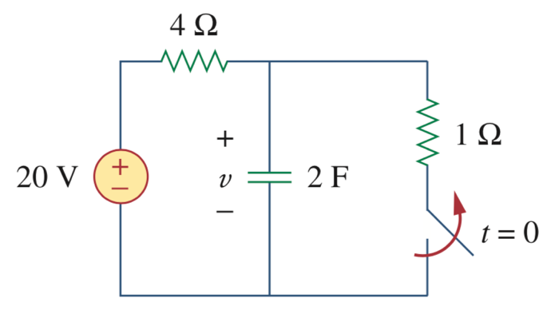

Figure 4-2

Solution:

(1) The switch is off when t = 0, so before the change the circuit is in steady state. The voltage across the capacitor equals to the $1Ω$ resistor.

$$V_{c}(t) = 20 × \frac{1}{4+1} = 4 V$$

(2) As the switch turns off at zero time point, the voltage of capacitor can not change abruptly, so

$$V_{c}\left(0-\right)=V_{c}\left(0+\right)$$

$V_{c}\left(0+\right) = 4 V$

1. After a long period of time Vc should be equal to voltage source, so $V_{c}(∞)= 20 V$
2. The time constant $τ = RC = 4∙2 = 8s$

By the three elements, we could defer the $V_{c}(t)$ as,

$$V_{c}(t) =V_{c}(∞) +[V_{c}\left(0+\right) - V_{c}(∞)] e^{-t/τ} =20 + (4 - 20)e^{-t/8} = 20 - 16e^{-t/8} V$$